Jyle Darling, Willian Bernatzki Woellner, Travis Reeve

M093437, 30021175, 30017892

Rapid App Development

AT2 Master Document

Table of Contents

Sprint One 1

Source Control Snapshots 1

Project Management Plan (Sprint one) 6

Software Development Testing Plan 7

Purpose and Scope 7

SQA Team Roles and Responsibilities 7

Work Products to be Reviewed 7

SQA Task Schedule 7

Reference Materials 8

Standards and Methodology 8

Audits or Reviews 8

SQAP Checklist 9

Analysis Report 10

CITE Business rules 10

CITE Quality assurance 11

ACME Development requirements 11

Multi-Platform Report 12

Adaptive Design 12

Responsive Design 13

The Choice 13

Demonstration Images 2

Application Testing Documentation 3

Sprint Two 4

Sprint Three 5

Sprint One

Scrum Master Jyle Darling

# Source Control Snapshots

Current Project status can be viewed at: <https://github.com/Jely101/RAD/projects/1>

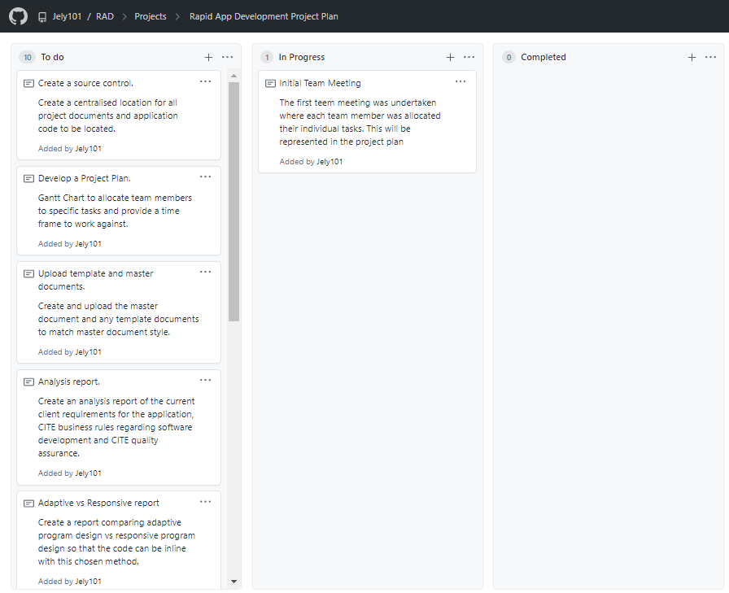

Figure 1 Project development cards. Taken at the end of the first meeting.

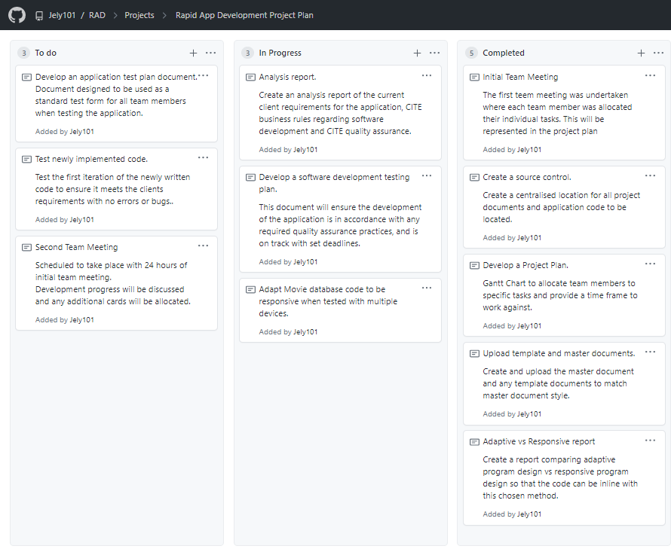

Figure 2 Project development cards. Taken at the end of the first day.

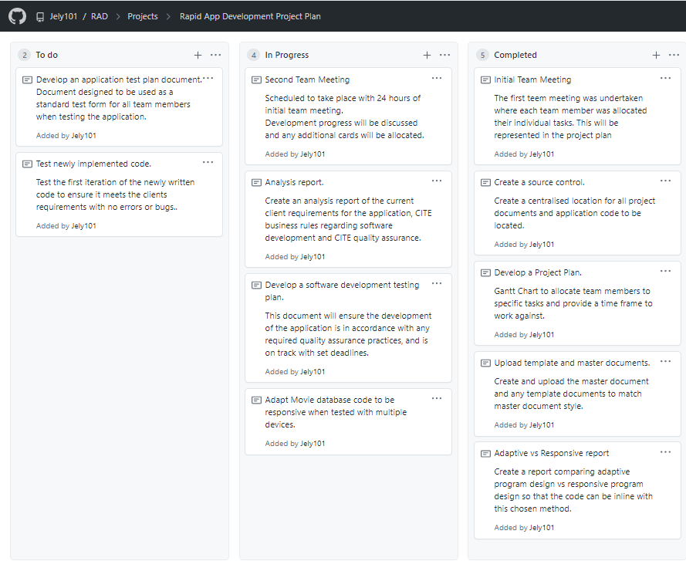

Figure 3 Project development cards. Taken at the end of the second team meeting.

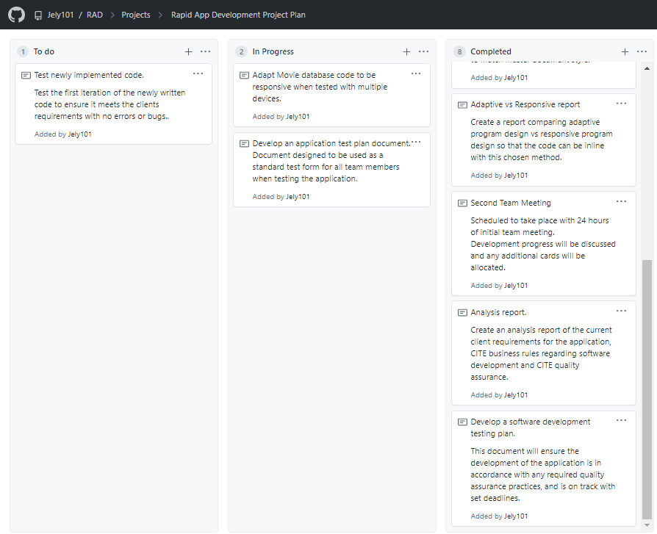

Figure 4 Project development cards. Taken at the end of the second day.

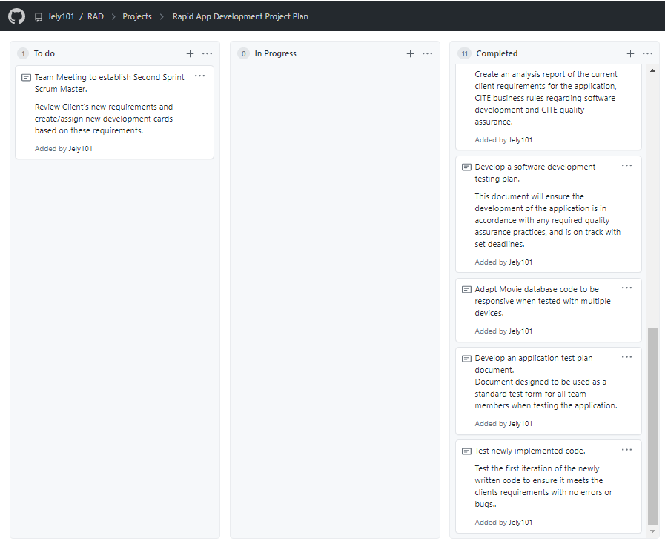

Figure 5 Project development cards. Taken at the end of the fifth day.

# Project Management Plan (Sprint one)

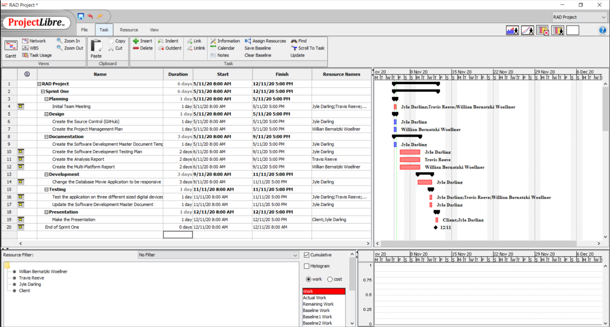

The current project plan can be accessed and downloaded at:

<https://github.com/Jely101/RAD/blob/main/Project%20Management%20Plan.pod>

# Software Development Testing Plan

## Purpose and Scope

This Software Quality Assurance Plan provides a foundation for managing the CITE Manages Services (CITE MS) software quality assurance activities and is based on project activities and work products as documented in the CITE MS Project Plan.

This plan:

• Identifies the SQA responsibilities of the project team.

• Defines CITE MS reviews and audits and how they will be conducted.

• Lists the activities, processes, and work products that the SQA team will review and audit.

• Identifies the SQA work products.

## SQA Team Roles and Responsibilities

|  |  |  |  |
| --- | --- | --- | --- |
| **Number** | **Member** | **Roles** | **Responsibility** |
| 1 | Jyle | SQA Leader | Develop and document quality standard and process for all management process  Manage software quality assurance activities for the project. |
| 2 | Travis | SQA Auditor | Perform SQA tasks, report to SQA leader the result of SQA review. |
| 3 | Willian | SQA Auditor | Perform SQA tasks, report to SQA leader the result of SQA review. |

## Work Products to be Reviewed

|  |  |  |  |  |
| --- | --- | --- | --- | --- |
| **Number** | **Development Phase** | **Product** | **Permission** | **Granted to Person** |
| 1 | Sprint One | Management plan | Read | Jyle |
| 2 | Sprint One | Analysis Report | Read | Jyle |
| 3 | Sprint One | Multi-platform report | Read | Travis |
| 4 | Sprint One | Software Development test report | Read | Willian |
| 5 | Sprint One | Application test reports | Read | SQA Team |

## SQA Task Schedule

|  |  |  |  |
| --- | --- | --- | --- |
| **Date** | **SQA Task** | **Person In charge** | **Description** |
| 6/11/20 | Evaluate Management plan | Jyle | Analysis report review, project plan review. |
| 6/11/20 | Review multi-platform report | Travis | Review Multi-platform report. |
| 9/11/20 | Review Software Development test report. | Willian | Review software development test report. |
| 11/11/20 | Review application test reports | SQA team | Review application test reports. |

## Reference Materials

Reference materials used to develop the CITE MS SQAP include:

* ISO/IEC/IEEE 12207:2017 Systems and software engineering — Software life cycle processes.
* CITE Managed Services Quality Management Policies and Procedures.

## Standards and Methodology

The following standards or methodologies were used to train team members in order to better prevent against any defects from occurring in the management and development process. These standards were taken from CITE Managed Services, in accordance with our ongoing contract.

* IEEE Guide to Software Requirements Specifications
* IEEE Guide to Software Design Descriptions
* IEEE Standard for Software User Documentation
* INITIATION AND PLANNING - Project specification analysis, test plan elaboration and team assignment.
* FIRST REVIEW - Initial testing of first development deliverables, refining the test plan and test items.
* ITERATION AUDITS - Ongoing testing of intermediate iterations builds.
* FINAL VERIFICATION AND VALIDATION - Final product testing to ensure bespoke quality and readiness for deployment.

## Audits or Reviews

Quality Assurance for this project will include at least one audit of all current draft deliverables and selected work products in each stage of development. The reviews will assure that the established system development and project management processes and procedures are being followed effectively, and exposures and risks to the current Project Plan are identified and addressed.

The following diagram depicts the In-Stage Assessment process flow for all CITE MS development stages:

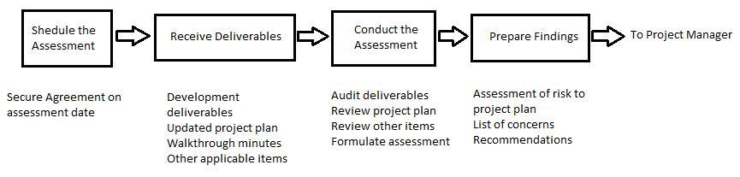

Each deliverable and/or selected work product will be audited to make judgements as to the quality and validity of the deliverable or work product. The assessment will include any verification or validation activities performed since the last In-Stage Assessment.

## SQAP Checklist

|  |  |  |  |
| --- | --- | --- | --- |
| **Software Quality Assurance Activity** | **Yes** | **No** | **N/A** |
| I. Project Plan |  |  |  |
| Team meeting to discuss project requirements | X |  |  |
| Project requirements allocated amongst team members | X |  |  |
| Project plan provides clear guidance on time frames expected of each task | X |  |  |
| Project plan was completed on time | X |  |  |
| Project plan meets expected QA guidelines | X |  |  |
|  | | | |
| II. Analysis Report |  |  |  |
| Application requirements are identified and defined | X |  |  |
| CITE MS Business rules are defined | X |  |  |
| CITE MS Quality Assurance practices are defined | X |  |  |
| Report is completed on time | X |  |  |
| Report meets expected QA guidelines | X |  |  |
|  | | | |
| III. Multi-platform Report |  |  |  |
| Report provides descriptions of each development method | X |  |  |
| Report provides pros and cons for each development method | X |  |  |
| Report provides a clear reason for the chose development method | X |  |  |
| Report was completed on time | X |  |  |
| Report meets expected QA guidelines | X |  |  |
|  | | | |
| IV. Software Development Test Report |  |  |  |
| Report identifies the SQA responsibilities of the project team. | X |  |  |
| Report Defines CITE MS reviews and audits and how they will be conducted. | X |  |  |
| Report Lists the activities, processes, and work products that the SQA team will review and audit. | X |  |  |
| Report Identifies the SQA work products. | X |  |  |
| Report was completed on time | X |  |  |
| Report meets expected QA guidelines | X |  |  |
|  | | | |
| V. Application Test Reports |  |  |  |
| Sufficient number of test cases were conducted to ensure product meets client requirements | X |  |  |
| Each team member assigned completed their report on time | X |  |  |
| Reports meet expected QA guidelines | X |  |  |

# Analysis Report

## CITE Business rules

CITE managed services has a set of business rule that define the development process for all projects. These business rules include.

* Client’s interests always come first.
* We are performance orientated and unafraid to make decisions and be accountable for those decisions.
* Without compromise we will operate in an ethical manner and in compliance with regulations.
* We aim to deliver the best products and service in the market.
* We will constantly strive to find a better solution to a client’s problem.
* Individual creativity is encouraged to create a great team working environment.
* Be capable of undertaking the largest projects our clients could conceive while remaining small enough to maintain the loyalty and comradery of all of our clients.
* We anticipate changes in the markets and technologies and will deliver the latest service, tools and technologies to our clients.
* While we strive to grow our business aggressively, we will always be fair competitors and will never denigrate other firms.
* We expect our people to maintain high ethical standards in everything they do.

## CITE Quality assurance

CITE managed services has a quality management system comprising a complex set of engineering and managerial activities that ensure bespoke quality of delivered software throughout the entire workflow. Their procedures and regulations are based on industry standards and best practices. Product lifecycle monitoring ensures compliance with processes and guidelines. Product quality verification and validation ensures all products comply with client business needs and expectations. CITE promotes effective collaboration between all project team members. To ensure all CITE software is of a high quality all project follow these steps in quality management.

Quality planning – A plan that govern the applicable set of standards, regulations, procedures, guidelines and tools during the development lifecycle in each project.

Quality assurance – Established processes that evaluate project performance and aim to assure that quality standards are being followed and that the deliverables comply with customer requirements.

Quality control – Measuring performance trends to identify defective pieces of code, verify that deliverables are of a high quality and that they are complete and correct.

CITE has an independent quality assurance department responsible for full-cycle quality testing, document and code reviews, defect tracking, configuration management process monitoring and risk management. A lead quality specialist is involved in initial business analysis and requirement specifications on all projects. The quality assurance team will provide reports on functional and regression testing, GUI and usability testing, accessibility testing, compatibility testing, performance testing, installation and configuration testing, system and integration testing, security testing, localization and internationalization testing and user acceptance testing.

## ACME Development requirements

The development requirements for this Movie Database application are.

* Use a RAD and agile software lifecycle methodology for development.
* Must be usable across all major digital platforms.
* A Multi-platform report on the merits of the two design options, adaptive and responsive.
* Rework the prototype to use the chosen design option.
* Movie database hosted on cloud or local server.
* A testing plan for the prototype.

# Multi-Platform Report

## Adaptive Design

Adaptive designs consist of multiple renditions of the same design – one for each size, as chosen by the designer or UI developer. Each version of the design is assigned to specific browser widths, called ‘anchor points’. Anchor points tell the browser exactly when to jump to the next layout. (Erickson, 2020)

Instead of using percentages, an adaptive design will utilize exactly one static layout per each anchor point, and adjust to the screen size once that anchor point has been detected. (Erickson, 2020)

Adaptive design can be complex because the designers have to create some different designs on the same page.

Pros and Cons of Adaptive Design. (Charlton, 2014)

|  |  |
| --- | --- |
| **Pros** | **Cons** |
| Super-efficient page loads: Adaptive websites are much better for load time performance and overall user experience. This is because adaptive delivery works by only transferring those assets necessary for the specific device and optimizing images and multimedia content on the fly to suit display resolution and size. | Resource and budget heavy: Adaptive requires a large team of developers and the budget to handle the complexity that comes with choosing to develop and support an adaptive site. |
| No need to scratch your existing website completely: Developers don’t have to go back to the drawing board and re-code the existing website from scratch. | Complexity: Adaptive is a good approach, but creating too many separate designs takes a lot of work and can defeat the purpose of trying to use one set of content on one URL. |

## Responsive Design

In Responsive Design, a website will change its appearance based on the viewport of the browser. Typically developers use the width of the browser as the variable which determines the size of the dynamically changing elements on the page. (Erickson, 2020)

A responsive website is entirely fluid and will adjust and respond to the viewport no matter the size of the browser window (or screen). That is because it uses percentage-based CSS rules to change the style based on the device size. (Erickson, 2020)

Pros and Cons of Adaptive Design. (Jia, 2017)

|  |  |
| --- | --- |
| **Pros** | **Cons** |
| Save cost on responsive web design development: Comparing with the development of websites on PC, iPad, and mobile phones, responsive design is more conducive to saving design and development costs. | Slow down the loading: It will take longer to load for some responsive websites. It’s not a big deal because some unnecessary HTML/CSS will be loaded. |
| User experience friendly: The responsive design can provide users with a friendly web interface, as it can adapt to almost all devices on the screen, including smartphones, tablets, TV, PC monitors, iPhone, and Android phones which contribute to the mobile-friendly website design. | Bad compatibility for the old version of the IE browser: If the site users are mostly using the old version of IE, it is not recommended to do responsive design. |

## The Choice

Analysing the whole scenario of the application, where it needs to be across all major digital devices, the choice of the developer team is the Responsive Design. The main points for this choice are:

* The current website is easier to change to Responsive Design
* There are many templates available to use in a future change. For example Bootstrap
* There is no need for many developers to make the change.
* The development time is less than use Adaptive Design.
* The cost of the project is less because the time is less and there are fewer resources involved in the project.

# Demonstration Images

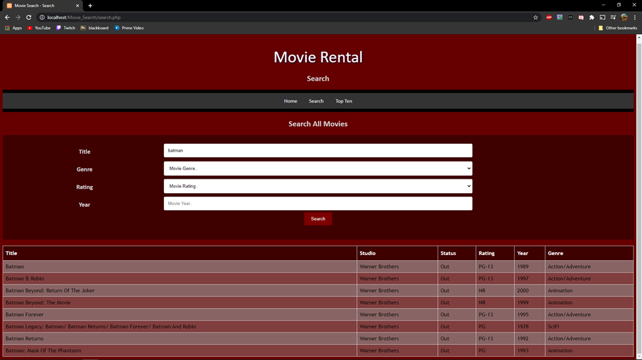

Figure 6 Desktop view of Search function and table populated with results.

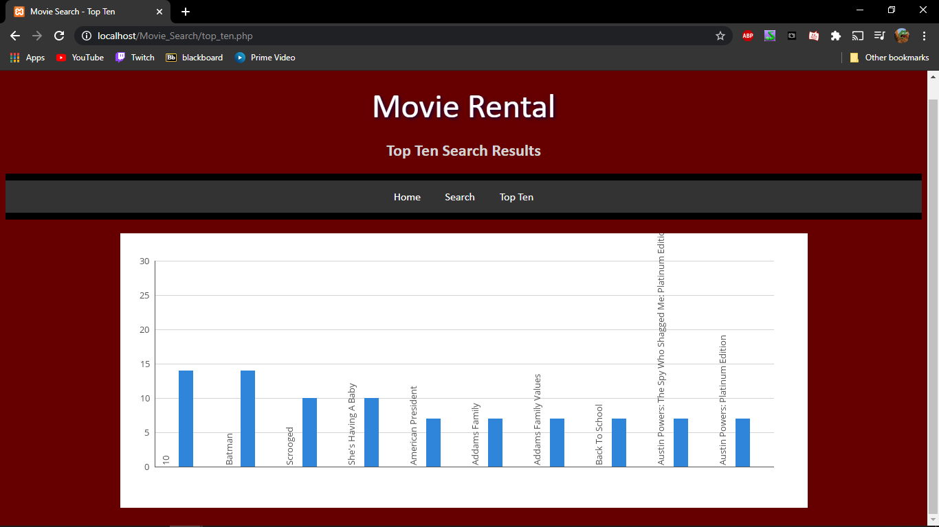

Figure 7 Desktop view of top ten chart populated with results.

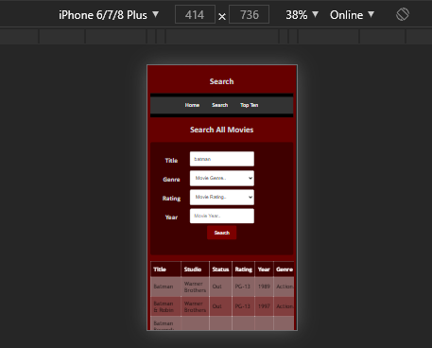

Figure 8 iPhone 6/7/8 Plus device view showing search function with search table results

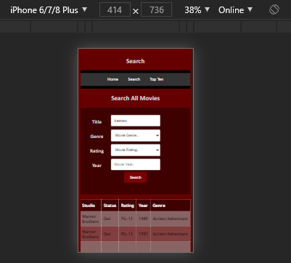

Figure 9 iPhone 6/7/8 Plus device view showing search function with search table results scrolled to show end of table.

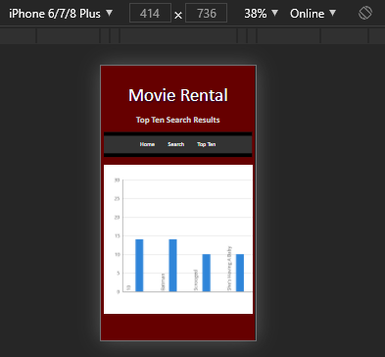

Figure 10 iPhone 6/7/8 Plus device view showing top ten search results image.

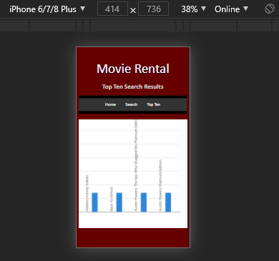

Figure 11 iPhone 6/7/8 Plus device view showing top ten search results scrolled to show rest of image.

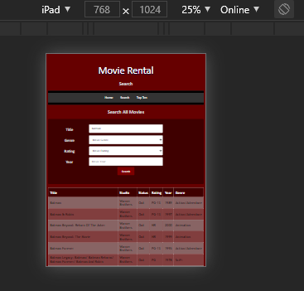

Figure 12 iPad device view showing search function with search table results.

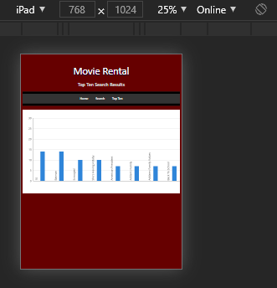

Figure 13 iPad device view showing top ten search results image.

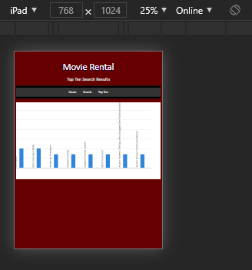

Figure 14 iPad device view showing top ten search results scrolled to show rest of image.

# Application Testing Documentation

Tester Jyle Darling

|  |  |  |  |  |
| --- | --- | --- | --- | --- |
| **Test Case** | **Description** | **Expected Result** | **Actual Result** | **Comments** |
| 01. Testing webpages load on different devices | Chrome used to load the various webpages on different devices using the device toolbar within the F12 menu. | Webpages load and display as normal, images or charts scroll correctly when devices with screen sizes smaller than image or chart size. | As expected | Ref to demonstration images. |
| 02. Searching for movie by Title. | Searching the database for a movie only using the movie title. Search term is in the database. | Table to be shown with search results. | As expected | Ref to demonstration images. |
| 03. Searching for movie by Genre. | Searching the database for a movie only using the movie Genre. | Table to be shown with search results. | As expected | Ref to demonstration images. |
| 04. Searching for movie by Rating. | Searching the database for a movie only using the movie Rating. | Table to be shown with search results. | As expected | Ref to demonstration images. |
| 05. Searching for movie by Year. | Searching the database for a movie only using the movie Year. | Table to be shown with search results. | As expected | Ref to demonstration images. |
| 06. Searching for movie by combination of title, Year. | Searching the database for a movie using the movie Title and Year. | Table to be shown with search results. | As expected | Ref to demonstration images. |
| 07. Searching for movie by combination of Genre, Rating | Searching the database for a movie using the movie Genre and Rating. | Table to be shown with search results. | As expected | Ref to demonstration images. |
| 08. Top ten has updated. | Checking to see if the top ten list has updated with the extra searches. | New top ten chart to be shown with different values based on the new search terms. | AS expected | Ref to demonstration images. |

Sprint Two

Scrum Master

Sprint Three

Scrum Master